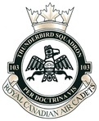

103 Thunderbird Squadron would like to invite you too the

NCO Training Course
Graduation Parade
2017

To be held on February 13th, 2017 at the J.P. Fell Armory in North Vancouver.

Invitation for 1315hrs and to be seated for 1330hrs. We hope to see you there.

Cadets should be dismissed around 1500hrs.
On behalf of 103 Thunderbird Squadron Staff.

